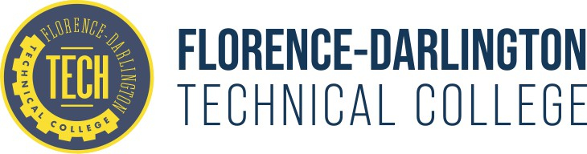

MEDICAL LABORATORY TECHNOLOGY (MLT) PROGRAM OUTCOMES

|  |  |  |  |  |  |
| --- | --- | --- | --- | --- | --- |
| Year | 2021 May  Graduates | 2022 May  Graduates | 2022 Dec.  Graduates | 2023 Dec.  Graduates | 2024 Dec.  Graduates |
| Graduation Rate | 100% | 87.5% | 100% | 91% | 87.5% |
| Certification Exam Pass Rate (ASCP) American Society of Clinical Pathology | 90.9% | 80% | 62.5% | 50% | 40% |
| Certification Exam Pass Rate (AMT) American Medical Technologist |  |  |  |  | 100% |
| Graduate Job Placement Rate | 100% | 85.5% | 88.8% | 90% | 87.5% |

The MLT Class of 2024 will be the final cohort to graduate in December. Beginning in Fall 2024, the program transitioned back to a five-semester curriculum. As a result, there will be no graduates in 2025. The next graduating class is scheduled for Spring 2026.

**Certification:** South Carolina does not require state licensure for laboratory professionals. All clinical affiliates recognize both the ASCP and AMT certifications as equivalent credentials for employment. Beginning in Fall 2024, several MLT program graduates elected to pursue the AMT certification exam rather than the ASCP exam.

**National Accrediting Agency for Clinical Laboratory Science (NAACLS) Benchmarks**

Graduate Rates Benchmark: Three year rolling average of a 70% graduation rate for students who have begun the final half of the program.

Graduate Certification Pass Rates: Benchmark: Three year rolling average of a 75% pass rate on BOC examinations (accredited programs) taken within first year of graduation.

Graduate Placement Rates: Benchmark: Three year rolling average of 70% of graduates finding employment or continuing education within one year of graduation.

The MLT Program at FDTC is fully Accredited by NAACLS. The next reaffirmation is 10-26-2027.

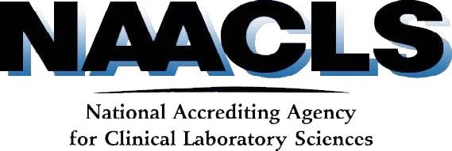 5600 N. River Road, Suite 720 Rosemont, IL 60018-5119 | Telephone (773-714-8880)